Date : 22-12-2025

Was testing for the fix done for issue reported on 21 -12 -2025

Dev confirmed that he has added the state parameter as fix

State Paremeter

state is a client-generated, opaque value that:

- Is sent in the authorization request
- Is returned unchanged by the IdP
- Is validated by the client after redirect

Why state parameter exists - Prevents the CSRF attacks on OAuth Flows

| Function | Why |
| ------------------ | ------------------------------------- |
| CSRF protection | Ensures auth response matches request |
| Session binding | Ties auth flow to browser session |
| Redirect integrity | Prevents auth response injection |
| Tenant context | Often embeds tenant / app info |

| Issue | Impact |
| ---------------------- | ---------------------------- |
| Missing `state` | OAuth CSRF |
| Static `state` | Predictable attack |
| Reusable `state` | Session fixation |
| Not validated | Full auth bypass possibility |
| Encoded sensitive data | Info leakage |

Initially check whether the state parameter mitigates the current attack ?

Starting the test

Request wothout state parameter - 400 Bad Request

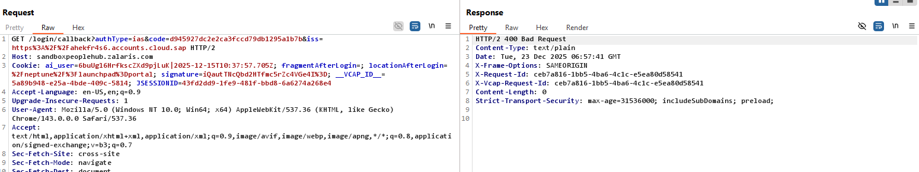

Request with empty state Parameter - 400 Bad request

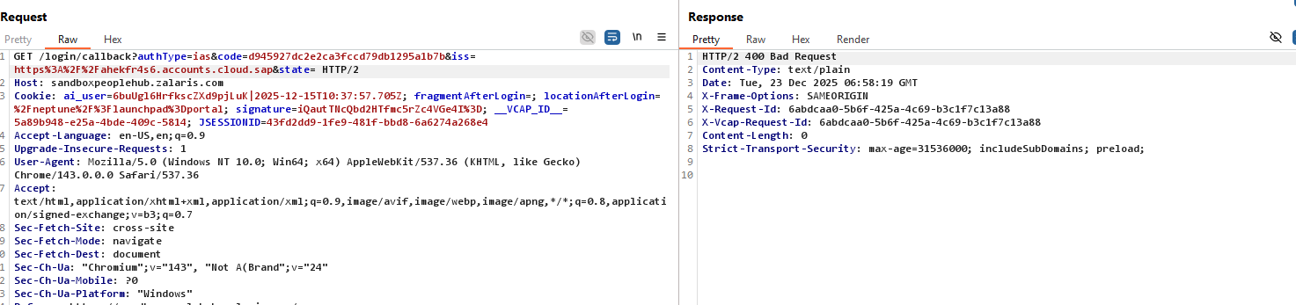

Request with tampered state Parameter - 400 bad Request

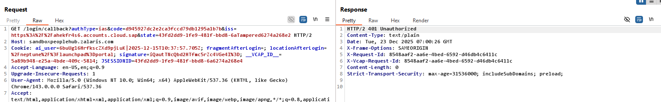

Captured Old State Parameter Accepted or Not -

State Parameter Captured during Time :

&state=43fd2dd9-1fe9-481f-bbd8-6a6274a268e2

Date: Tue, 23 Dec 2025 07:07:26 GMT

State Parameter Re-tried again Time :

Request sent timestamp : Date: Tue, 23 Dec 2025 07:13:24 GMT

Capture a valid Request state parameter and then resend using the old request - received 401 Unauthorized error

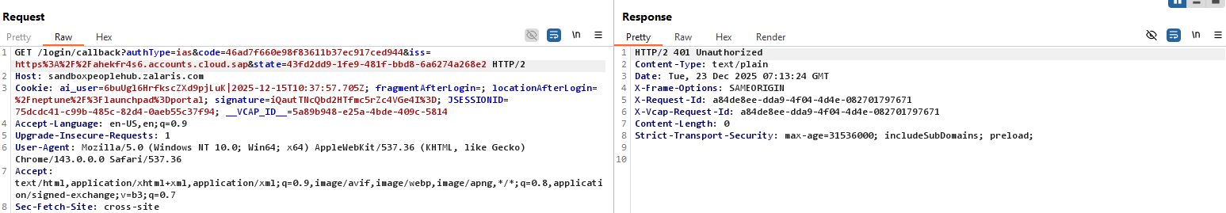

Just need to confirm whether the code can be swapped now to check the authentication to session binding

Need Pranesh for this process - once he I back we can test and have the result

Missing state parameter - no issues detected and getting 401 Unauthorized

The browser cookie is the link with the state parameter

Cross Browser session Check

- tested by generating the session cookie in browser and then called the url in another session - no issue was found

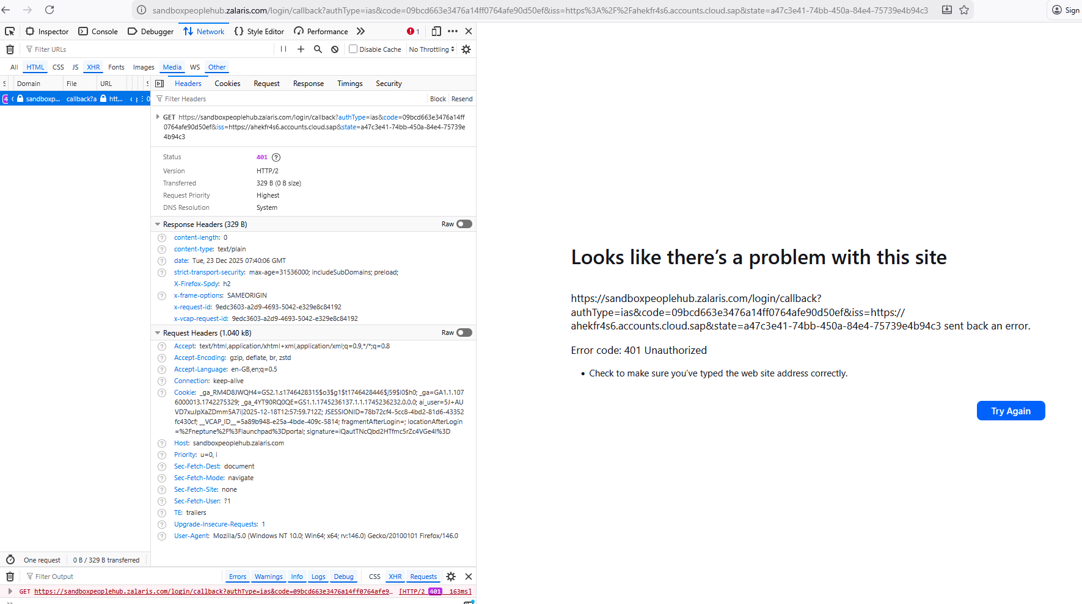

The state parameter is linked with the cookie and is checked - test by removing the cookies

State parameter is invalidated a single use - Yes

Started the request using mohammed.sharoz@zalaris.com

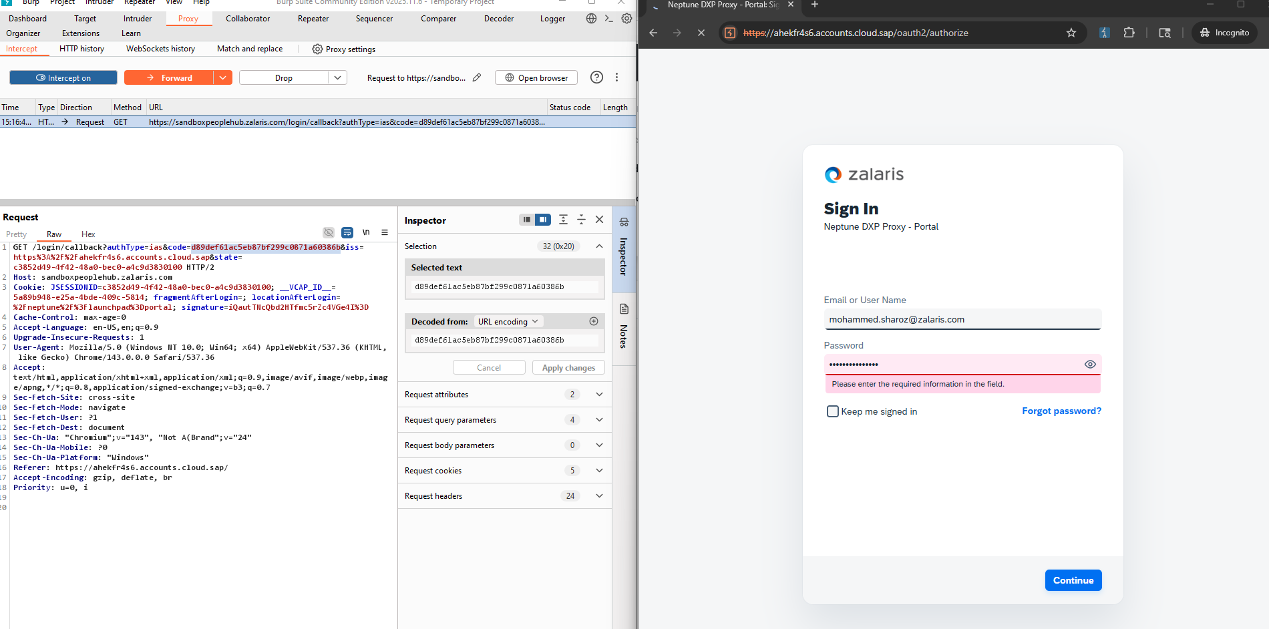

The server sends the auth-call back code

Get the auth code from user B

And send code for user B in User A request

Users B auth Code - 02d3e2cd623198cee2ee58c6e15d5936

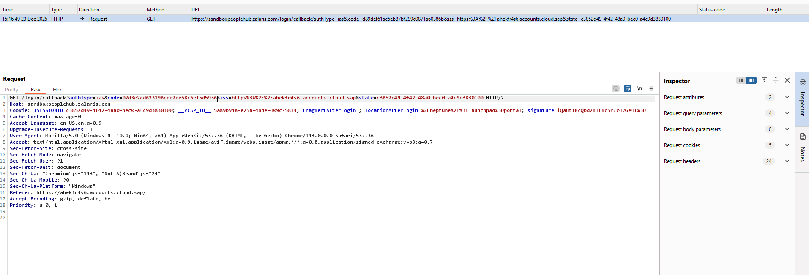

The flow initially succeeded - reason might be that state parameter is bound to the user session that is JSESSION ID

But one notable thing is that JSESSION ID - is the state Parameter - so it means - need to check whether I can send the JSESSION ID in other requests that can be used to get valid data ?

Lets test in cross browser session attack

Cross browser attack did not work - need to check once again

The server is responding with the changed authentication code only checks whether the state parameter remains as it is

For MOHS changed with Lucas able to received the code screenshot attached below

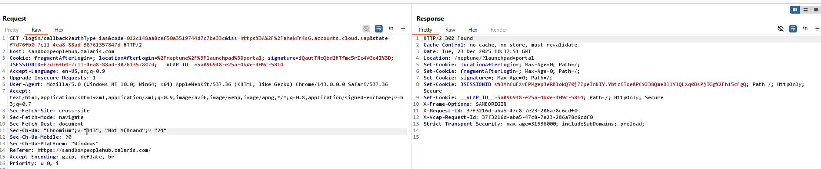

For Lucas able to get 302 from the server with MOHS code , screenshot attached below

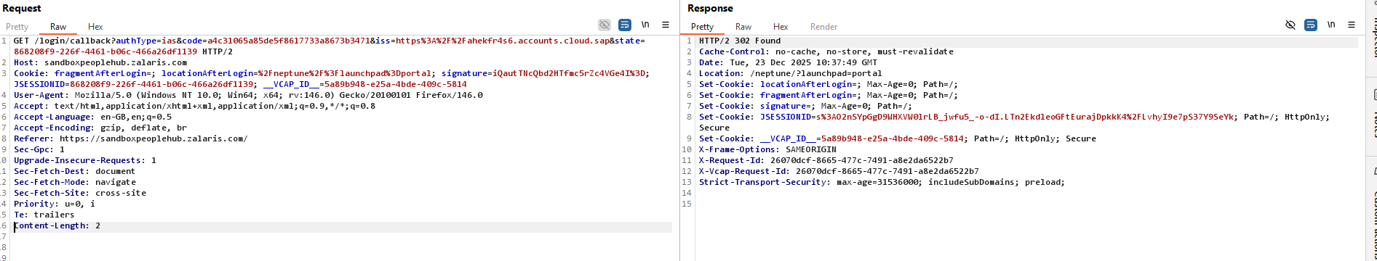

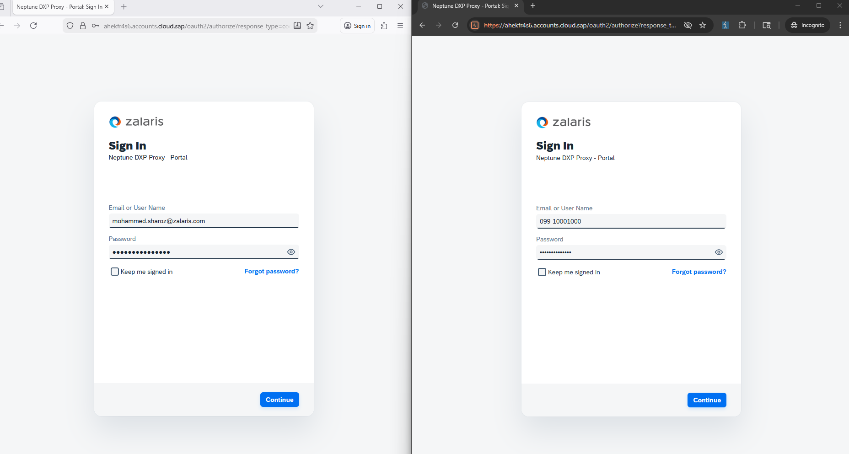

Still the code can be exchanged, this confirms that authentication to session binding is not successful

So the only option is that PKCE is not successful

